**INTELLIGENT CAREER SELECTION SYSTEM**

**ABSTRACT:**

* **Intelligent Career Selection System** will enable a more effective way to choose the career and to know the profession that will perfectly suit a person based on the Candidate’s Curriculum vitae.
* System will rank the area of interest, scores, projects details, workshop/seminars attended, organised events, competitions and other key skills and suggest the profession that match with the skills of the candidate ,the job opportunities in that profession and average salary in that profession.
* This system will help especially the students to select right job that matches the profile which helps to excel in the Career.
* This project can also be applied in a company to short list the submitted candidate CVs from a large number of applicants providing a consistent and fair CV ranking policy, which can be legally justified.
* This system will focus not only in qualification and experience but also focuses on other important aspects which are required for particular job position.
* This system will help the HR department to easily shortlist the candidate based on the CV ranking policy

**Problem Statement:**

1. Finding the profession in which a person possesses talent, interest is a challenging task in deciding Career. Due to lack of self realization and misguidance (others cannot correctly understand the talent, interest of a person) even talented person fail to choose a right Career.
2. Many Multinational Companies spend a lot of time and Human efforts in short listing Candidates for a particular job position.

**Existing Solution:**

* Students get general guidance from experts which may or may not suit an individual.
* Interview panel spend a lot of time to shortlist CV manually.
* There is no proper existing system.

**Objective:**

* To Develop a system which helps an individual to choose a right profession based on the person’s interest and talent required for that profession and make aware of job opportunities and average salary in that profession
* To make Recruitment process easy by making use of the Intelligent Career Selection system to Shortlist Candidates.

**Proposed Methodology:**

* In Intelligent Career Selection system we get the candidates detailed Curriculum Vitae.
* From the evaluation of CV we identify in which field the Candidate is interested and in which field the Candidate is really talented.
* Now, Our Trained system will guide the Candidate to choose the right profession that suits the best.
* It also gives information about available job opportunities and average salary in that profession, scope in that profession.

**Technology stack:**

* First apply tokenization algorithm to tokenize the CV.

Optimized lines of code used in tokenization algorithm

* Next apply POS algorithm to extract nouns to identify the skills of that Candidate
* Then find the key skills of the Candidate in the CV by using aggregate function algorithms
* Rank the skills by using Naïve Bayes algorithm.
* Then use Naïve Bayes algorithm and train the system to suggest the profession based on the Candidates skill

Naïve Bayes Algorithm is very efficient for small size inputs.

Naïve Bayes Algorithm requires less time to train the model

It is simple and if the conditional independence assumption actually holds, a Naive Bayes classifier will converge quicker than discriminative models like logistic regression, so you need less training data. And even if the NB assumption doesn’t hold

* Use Web Browser API to suggest the available jobs in that Profession.

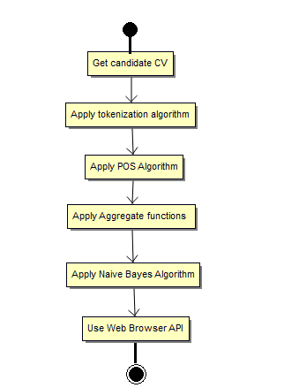

**Features and Scope of the Project:**

* Candidate choose right profession
* Candidate can be updated with available job opportunities
* Identify the key Skill and strength of the Candidate
* Help Interview panel to save time, effort.
* This can be employed in IT industries and other industries to Shortlist right Candidates, in Colleges for Student’s Career guidance.

**OUTPUT OBTAINED:**

Anaconda Prompt-python

(C:\Users\Computer\Anaconda3 ) : C:\Users\Computer>python

Python 3.6.0 |Anaconda 4.3.1 (64-bit)| (default, Dec 23 2016, 11:57:41) [MSC v.1900 64 bit (AMD64)] on win32

Type "help", "copyright", "credits" or "license" for more information.

>>> import nltk

>>>file_contents = open("C:/Users/user/Desktop/sresume.txt").read() #specify the location of sresume attached in this github in your PC otherwise it throws file not found error

>>>is_noun=lambda pos: pos[:2] == 'NN'

>>> tokenized=nltk.word_tokenize(file_contents)

>>>nouns=[word for (word,pos) in nltk.pos_tag(tokenized) if is_noun(pos)]

>>>print(nouns)

['SKILL', 'SET', 'Programming', 'Systems', 'WINDOWS', 'Ubuntu', 'AREA', 'INTEREST', 'C-Programming', 'TECHNICAL', 'ACHIVEMENTS', '•', 'Attended', 'Short', 'term', 'Course', 'Technologies', 'software', 'development', 'C-Programming', 'project', 'Burger', 'Alarm', 'C-programming', 'Mini', 'Project', 'Contest', 'Innovation', 'Inclusive', 'Growth', 'Sept', '•', 'C-programming', 'Challenge', 'Event', 'i3indya', 'Technologies', 'association', 'Radiance', 'IIT', 'Bombay', 'research', 'paper', 'eVision', '’', 'International', 'Research', 'Journal', 'Engineering', 'Technology', 'IRJET', 'Volume', 'Issue', 'August', 'term', 'course', 'C-programming', '•', 'Got', 'NPTEL', 'certification', 'ACHIEVEMENTS', 'IN', 'CO-CURRICULAR', 'AND', 'EXTRA', 'CURRICULAR', 'ACTIVITIES', '•', 'Won', 'First', 'Prize', 'Slogan', 'Contest', 'Traffic', 'awareness', 'programme', 'ROTARACT', 'CLUB', 'KLN', 'College', 'Engineering', '•', 'Pattimandram', 'Founder', '’', 'Day', 'Programme', '•', 'Pattimandram', 'Teacher', '’', 'Day', 'Programme', '•', 'events', 'PPT', 'C-programming', 'CODE', 'CHEF', 'QUIZ', 'CONNEXTION', 'FLIP', 'FLOP', 'Velammal', 'College', 'Engineering', '•', 'Winner', 'contest', 'Winner', 'English', 'Tamil', 'Elocution', 'Competitions', 'school', 'level', 'Winner', 'School', 'level', 'Dance', 'Competition', 'Winner', 'Essay', 'Writing', 'Competition', 'English', 'school', 'level', 'place', 'District', 'Level', 'YOGA', 'Competition', 'Regional', 'art', 'centre-Tirunelveli', '•', 'National', 'Level', 'Talent', 'Search', 'Examination', 'JCI', 'India', 'C-programming', '•', 'Participated', 'C-programming', 'Selvalaya', 'Charitable', 'Trust', '•', 'Secured', 'Second', 'place', 'Chair', 'Competition', 'school', 'level', '•', 'National', 'level', 'AQUQ', 'REGIA', 'science', 'quiz', 'T.I.M.E', '•', 'Youngsters', 'day', 'Competition', 'Sri', 'Ramakrishna', 'Association', 'Chennai', '•', 'C-programming', 'contest', 'School', 'Level', 'Competitions', '•', 'article', 'QUEST', 'THE', 'HINDU', 'Newspaper', 'education', 'programme', 'C-programming', '•', 'C-programming', 'CompuGen', 'course', 'study', 'Computer']

>>> nouns1 = ' '.join(nouns)

>>>print(nouns1)

SKILL SET Programming Systems WINDOWS Ubuntu AREA INTEREST C-Programming TECHNICAL ACHIVEMENTS • Attended Short term Course Technologies software development C-Programming project Burger Alarm C-programming Mini Project Contest Innovation Inclusive Growth Sept • C-programming Challenge Event i3indya Technologies association Radiance IIT Bombay research paper eVision ’ International Research Journal Engineering Technology IRJET Volume Issue August term course C-programming • Got NPTEL certification ACHIEVEMENTS IN CO-CURRICULAR AND EXTRA CURRICULAR ACTIVITIES • Won First Prize Slogan Contest Traffic awareness programme ROTARACT CLUB KLN College Engineering • Pattimandram Founder ’ Day Programme • Pattimandram Teacher ’ Day Programme • events PPT C-programming CODE CHEF QUIZ CONNEXTION FLIP FLOP Velammal College Engineering • Winner contest Winner English Tamil Elocution Competitions school level Winner School level Dance Competition Winner Essay Writing Competition English school level place District Level YOGA Competition Regional art centre-Tirunelveli • National Level Talent Search Examination JCI India C-programming • Participated C-programming Selvalaya Charitable Trust • Secured Second place Chair Competition school level • National level AQUQ REGIA science quiz T.I.M.E • Youngsters day Competition Sri Ramakrishna Association Chennai • C-programming contest School Level Competitions • article QUEST THE HINDU Newspaper education programme C-programming • C-programming CompuGen course study Computer

>>> nouns2 = nouns1.replace("•"," ")

>>>print(nouns2)

SKILL SET Programming Systems WINDOWS Ubuntu AREA INTEREST C-Programming TECHNICAL ACHIVEMENTS Attended Short term Course Technologies software development C-Programming project Burger Alarm C-programming Mini Project Contest Innovation Inclusive Growth Sept C-programming Challenge Event i3indya Technologies association Radiance IIT Bombay research paper eVision ’ International Research Journal Engineering Technology IRJET Volume Issue August term course C-programming Got NPTEL certification ACHIEVEMENTS IN CO-CURRICULAR AND EXTRA CURRICULAR ACTIVITIES Won First Prize Slogan Contest Traffic awareness programme ROTARACT CLUB KLN College Engineering Pattimandram Founder ’ Day ProgrammePattimandram Teacher ’ Day Programme events PPT C-programming CODE CHEF QUIZ CONNEXTION FLIP FLOP Velammal College Engineering Winner contest Winner English Tamil Elocution Competitions school level Winner School level Dance Competition Winner Essay Writing Competition English school level place District Level YOGA Competition Regional art centre-Tirunelveli National Level Talent Search Examination JCI India C-programming Participated C-programming Selvalaya Charitable Trust Secured Second place Chair Competition school level National level AQUQ REGIA science quiz T.I.M.E Youngsters day Competition Sri Ramakrishna Association Chennai C-programming contest School Level Competitions article QUEST THE HINDU Newspaper education programme C-programming C-programmingCompuGen course study Computer

>>>word_counter = {}

>>>for word in nouns2.split():

... if word in word_counter:

... word_counter[word] += 1

... else:

... word_counter[word] = 1

...

>>>highest_words = []

>>>highest_value = 0

>>>

>>>for k,v in word_counter.items():

... if v >highest_value:

... highest_words = []

... highest_words.append(k)

... highest_value = v

... elif v == highest_value:

... highest_words.append(k)

...

>>>for word in highest_words:

... print(word)

...

C-programming

>>> import webbrowser

>>> import time

>>> import webbrowser

>>> import time

>>>defnaive_bayes(word):

... if word == 'C-programming' or 'C++-programming' or 'Python-programming' or 'Java-programming':

... print('Software Developer')

... print('Software Engineer')

... time.sleep(3)

... webbrowser.open("https://www.google.co.in/search?ei=LA51W__4D9CsrQHIwp_wDg&q=job+opportunities+for+software+engineers+passed+out&oq=job+opportunities+for+software+engineers+passed+out&gs_l=psy-ab.3...9862.17571.0.20361.0.0.0.0.0.0.0.0..0.0....0...1c.1.64.psy-ab..0.0.0....0.3o079rtVjIc&ibp=htl;jobs&sa=X&ved=2ahUKEwi57L-K7vDcAhXLeX0KHQOSCi4QiYsCKAF6BAgFEB8#fpstate=tldetail&htidocid=v1YpM8KFvPGgB-IlAAAAAA%3D%3D&htivrt=jobs")

... elif word=='IOT' or 'Internet':

... print('IOT Developer')

... print('IOT Architect')

... time.sleep(3)

... webbrowser.open("https://www.google.co.in/search?q=job+opportunities+for+IOT+&ibp=htl;jobs#fpstate=tldetail&htidocid=hpTFt1s6sUAcdL8bAAAAAA%3D%3D&htivrt=jobs")

... elif word == 'HTML' or 'HTML5' or 'Javascript' or 'CSS' or 'CSS3':

... print('Web Developer')

... print('Web Programmer')

... print('Web Designer')

... time.sleep(3)

... webbrowser.open("https://www.google.co.in/search?q=jobs+for+web+technology&oq=job+opportunities+for+web+technolo&aqs=chrome.1.69i57j0.22353j0j7&sourceid=chrome&ie=UTF-8&ibp=htl;jobs&sa=X&ved=2ahUKEwio3vDtjfHcAhUCXysKHdqBCvcQiYsCKAF6BAgGECU#fpstate=tldetail&htidocid=RD0UlI-HteoVWvSDAAAAAA%3D%3D&htivrt=jobs")

... elif word == 'Data' or 'Database' or 'Datamining' or 'Data-analysis' or 'Data-warehouse' or 'Bigdata' or 'Cloud':

... print('Data Architect')

... print('Data Engineer')

... print('Cloud Engineer')

... print('Data Analyst')

... print('Data Consultant')

... print('Sales Engineer')

... time.sleep(3)

... webbrowser.open("https://www.google.co.in/search?newwindow=1&hl=en-IN&ei=yjR1W-DpGoXcrQG9-rioDQ&q=job+opportunities+for+big+data+google+jobs&oq=job+opportunities+for+big+data+google+jobs&gs_l=psy-ab.3...17306.22221.0.23620.12.12.0.0.0.0.1070.2085.2-2j5-1j0j1.4.0....0...1c.1.64.psy-ab..8.3.1012...0j0i22i30k1j33i22i29i30k1.0.-lF6UlBeMz8&ibp=htl;jobs&sa=X&ved=2ahUKEwizlJjykvHcAhXCeisKHZLxA0IQiYsCKAF6BAgHECQ#fpstate=tldetail&htidocid=3-Kry8Ne2x8KEnWIAAAAAA%3D%3D&htivrt=jobs")

... elif word == 'Robotics':

... print('Robotics Intergration Manager')

... time.sleep(3)

... webbrowser.open("https://www.google.co.in/search?newwindow=1&hl=en-IN&q=job+opportunities+for+robotics+google+jobs&ibp=htl;jobs#fpstate=tldetail&htidocid=Agd82NlXWSk_QgucAAAAAA%3D%3D&htivrt=jobs")

...

>>>naive_bayes(word)

Software Developer

Software Engineer

>>>naive_bayes(word)

Software Developer

Software Engineer

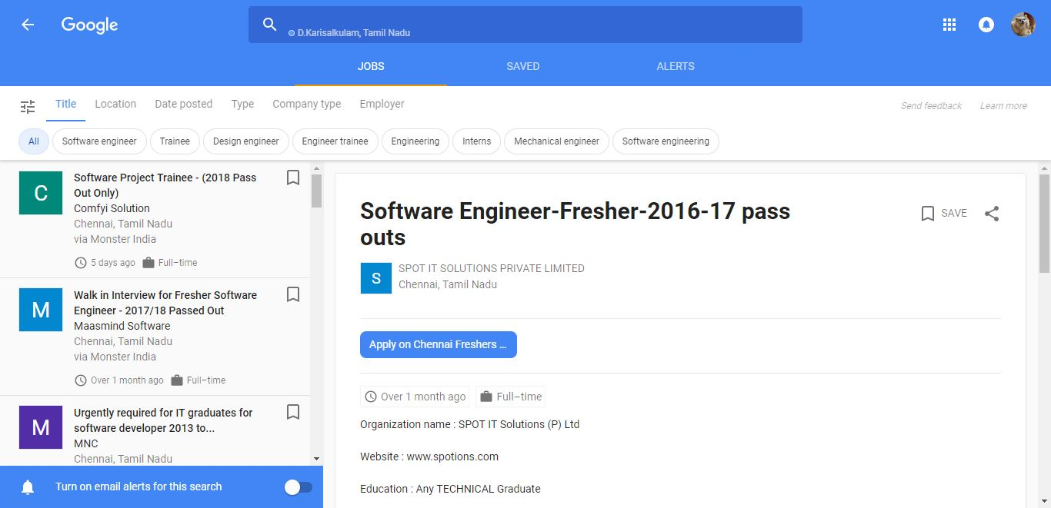

**Conclusion and future work:**

* This project is very useful to the Student community and MNC’s.
* In future this project can be developed as a mobile application to make it easy to access.
* In future, the app automatically gives information, once new vacancies are found in that profession and with the permission of the user it applies for the jobs.
* MNC can use this software to shortlist right Candidates without much Effort thereby saving time and money.
* In future, we can upload the CV of all the candidates in a folder and give folder as input and get the shortlisted Canditates rather than giving each Canditates CV one by bye in Recruitment process